Prelab 9 and 10

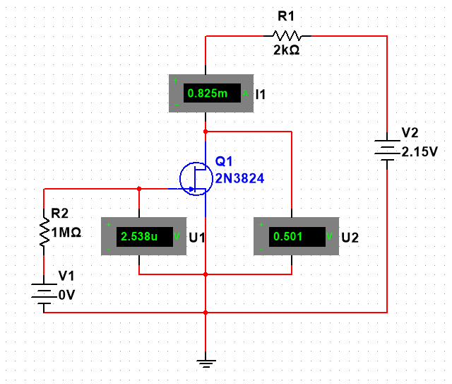

Circuit 9.1 JFET Circuit

|  |  |  |  |
| --- | --- | --- | --- |
| VDS (V) | Id (mA) @ VGS = 0V | Id (mA) @ VGS = -0.5 V | Id (mA) @ VGS = -1 V |
| 0 | 0 | 0 | 0 |
| 0.5 | 0.823 | 0.605 | 0.387 |
| 1 | 1.434 | 0.998 | 0.561 |
| 1.5 | 1.829 | 1.171 | 0.57 |
| 2 | 2.006 | 1.183 | 0.572 |
| 2.5 | 2.02 | 1.187 | 0.574 |
| 3 | 2.025 | 1.19 | 0.576 |
| 3.5 | 2.031 | 1.193 | 0.576 |
| 4 | 2.036 | 1.196 | 0.578 |
| 5 | 2.046 | 1.203 | 0.581 |
| 6 | 2.058 | 1.21 | 0.584 |
| 7 | 2.069 | 1.216 | 0.588 |
| 8 | 2.078 | 1.222 | 0.591 |
| 12 | 2.123 | 1.247 | 0.602 |
| 16 | 2.165 | 1.272 | 0.615 |
| 20 | 2.213 | 1.3 | 0.629 |

Table 9.1 Drain Characteristics

|  |  |
| --- | --- |
| VGS (V) | Id (mA) @ VDS = 6V |
| 0 | 2.058 |
| -0.5 | 1.22 |
| -1 | 0.593 |
| -1.5 | 0.188 |
| -2 | 0.011 |

Table 9.1 Transfer Characteristics

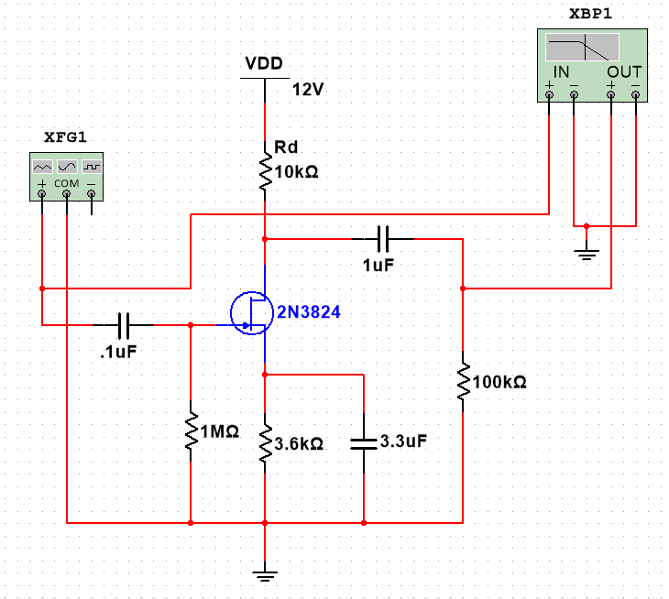

Figure 10.1 Small Signal Amplification

|  |  |  |  |
| --- | --- | --- | --- |
| Frequency (Hz) | Vin (mV) | Vout (mV) | Gain |
| 30 | 40 | 158.62 | 11.97 |
| 45 | 40 | 196.63 | 13.83 |
| 60 | 40 | 221.72 | 14.87 |
| 100 | 40 | 256.01 | 16.12 |
| 200 | 40 | 276.48 | 16.79 |
| 500 | 40 | 283.18 | 17.00 |
| 1000 | 40 | 284.39 | 17.04 |
| 10000 | 40 | 284.71 | 17.05 |
| 100000 | 40 | 284.71 | 17.05 |
| 500000 | 40 | 284.45 | 17.04 |
| 1000000 | 40 | 283.57 | 17.01 |
| 1500000 | 40 | 282.17 | 16.97 |
| 2000000 | 40 | 280.13 | 16.91 |
| 3000000 | 40 | 274.8 | 16.74 |
| 4000000 | 40 | 268.02 | 16.52 |
| 5000000 | 40 | 259.13 | 16.23 |
| 7000000 | 40 | 241.38 | 15.61 |
| 10000000 | 40 | 212.43 | 14.50 |
| 11000000 | 40 | 202.91 | 14.10 |
| 12000000 | 40 | 194.94 | 13.76 |
| 15000000 | 40 | 170.02 | 12.57 |
| 16000000 | 40 | 163.72 | 12.24 |

Table 10.1 Gain as a Function of Frequency